**Build a Workflow from Scratch with SAP Cloud Platform Workflow Management**DEV163

Prerequisite / Setup  
Archana Shukla / SAP

Table of ContentS

Overview 3

Setup Cloud Platform Account Using Booster 4

configure destination 4

IMPORT SAMPLE PROCESS CONTENT 6

# Overview

Estimated time: 15 minutes.

In this hands-on workshop you will be using your SAP Cloud Platform Trial account. You will learn how to model, manage and monitor workflow, business rules and process visibility capabilities of Workflow Management.

**Workflow Management** is a cloud offering from SAP which constitutes different capabilities that helps you to digitize your processes and decisions, and to get and end-to-end visibility into your processes. Not only this we are accelerating the productivity with infusion of intelligent technologies like Intelligent RPA, Conversational AI and providing ways to flexibly configure & extend the processes in a no-code low-code environment.

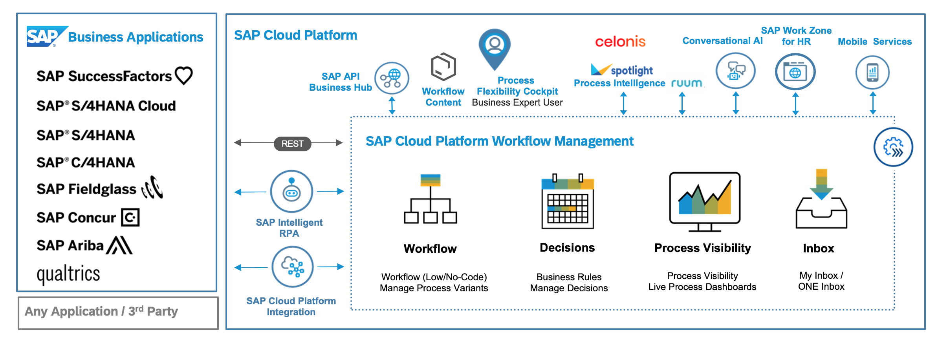

Before you start with the exercises, setting up your cloud platform trial account is an important prerequisite. With [Booster](https://help.sap.com/viewer/65de2977205c403bbc107264b8eccf4b/Cloud/en-US/fb1b56148f834749a2bf51127421610b.html), we have now fully automated the setup of workflow, business rules, process visibility and workflow management services in cloud platform environment. It does the following tasks which you would have otherwise done manually:

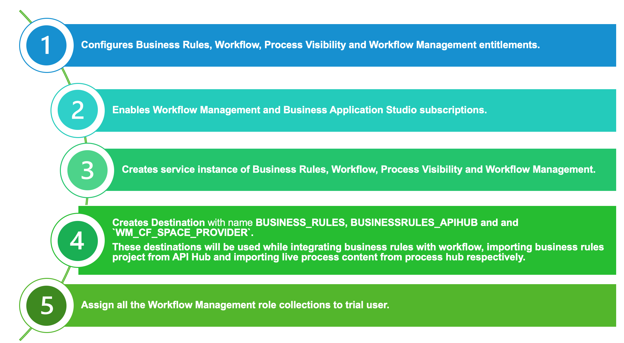

As part of the initial setup you will do the following to make your trial account ready to get started:

1. *Run the Workflow Management Booster.*
2. *Configure destinations to update your trial password.*
3. *Import & deploy sample workflow management scenario. This sample process content contains pre-built workflow, business rules and process visibility. These contents will be used in the exercises.*

# Setup Cloud Platform Account Using Booster

| Explanation | Screenshot |
| --- | --- |
| 1. Follow the tutorial to setup your account using Booster:   <https://developers.sap.com/tutorials/cp-starter-ibpm-employeeonboarding-1-setup.html> |  |

# configure destination

| Explanation | Screenshot |
| --- | --- |
| **WM_CF_SPACE_PROVIDER** destination is used in Process Flexibility Cockpit while importing the sample content from API Business Hub. This destination is already created in the previous set up tutorial, and now you will configure the destination for the password.   1. From your global account page, click the **trial** tile to access your subaccount. |  |
| 1. Click **Connectivity | Destinations** from the left-hand navigation and search for the destination with name **WM_CF_SPACE_PROVIDER.** Click on the destination to configure its properties. |  |
|
| 1. In **Destination Configuration** section, click **Edit** and enter your cloud platform trial user password.   Caution: Ensure that the **Two Factor Authentication** is disabled for the user whose username and password are entered in the destination configuration. If not, then register a new user with 2FA disabled.   1. Click **Save** to save the changes. |  |

# IMPORT SAMPLE PROCESS CONTENT

| Explanation | Screenshot |
| --- | --- |
| 1. In your sub-account, click **Subscriptions**, from the left-panel. 2. Search for **Workflow Management** and click on **Go to Application** link on the tile. |  |
| 1. From the Workflow Management Launchpad, click **Process Flexibility Cockpit** tile. |  |
| 1. Click **Discover Packages**. |  |
|
| 1. Search for **sample** and click on **Sample Capital Expenditure Approval Process.** |  |
| 1. Read the content overview to get information of the content and click on **Import**. 2. In the **Import Package** popup that comes, click on **Import** to continue. |  |
| Wait for the content to import. It will take 2-3 minutes for the content to be imported.  Once the content is import successfully, you will see the **Import** button changes to **Configure.**   1. Click on **My Live Processes** link on top left to go back the to Live Processes dashboard |  |
| 1. Click on the **Sample Capital Expenditure Approval Process** to navigate into the package to activate the business rules. |  |
| 1. As you go into the package, click on **DetermineLocalApprovers** rule from **Decisions** tile. |  |
| 1. In **the Manage Decisions** application, click on **Activate**. This will activate and deploy the business rules in your trial cloud account. |  |